Utilizing WAMMI Components to Evaluate the
Usability of the Airbnb Website
Ong Kai Xuen, Lim Si Ni, Soh Fei Zhen, Chan Qing Yee, Ooi Wei Sian
Faculty of Computing, University Teknologi Malaysia

Abstract - This study aims to assess the usability of the Airbnb website, a key player in the short-term accommodation rental market. Usability is paramount in ensuring that digital platforms align with user expectations and needs. Using real-world tasks, eye tracker heatmap and the WAMMI questionnaire, we evaluated the site's accessibility, functionality, and overall user experience. Our findings provide insights into the platform's strengths and weaknesses from a usability perspective. By identifying usability issues and areas for improvement, this research contributes to enhancing the user experience and optimizing user interactions on Airbnb's website. In an age where user-centric design is essential, this usability evaluation offers practical recommendations for refining online accommodation platforms like Airbnb, ensuring efficiency and satisfaction in user interactions.

Keywords - Usability Evaluation, User Experience (UX), Airbnb Website, User Feedback, User Interface(UI), WAMMI Questionnaire.

INTRODUCTION
Based on [1], usability is whether it provides the features you need. In the digital age, the usability and user experience (UX) of websites play a pivotal role in the success and satisfaction of users. This statement can be proven by several studies which are [2], [3] and [4]. This is especially pronounced in the realm of online platforms [5] facilitating short-term accommodation rentals. Airbnb, one of the industry's stalwarts, has reshaped the way individuals discover, book, and share accommodations worldwide [6]. This study aims to comprehensively evaluate the usability and user experience of the Airbnb website, guided by principles of user-centered design and accessibility.
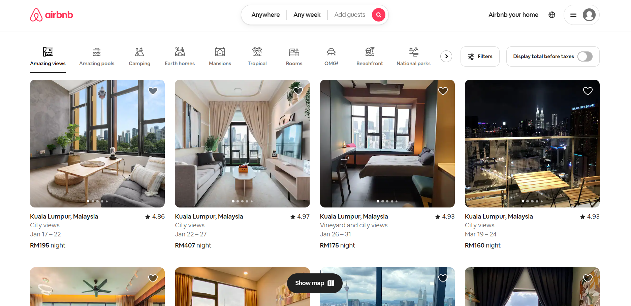
Figure 1: Airbnb website
The motivation behind this research is rooted in the paramount importance of UX and usability in online platforms like Airbnb, which have become integral to modern travel and accommodation experiences. Optimizing the usability of such platforms has far-reaching implications—it enhances the efficiency of user interactions, minimizes user frustration, and encourages sustained user engagement.
Our evaluation methodology encompasses real-world tasks, an eye tracker heatmap [7] and the renowned WAMMI (Website Analysis and Measurement Inventory) questionnaire [8] to scrutinize the platform's accessibility, functionality, and overall user experience. The key findings from this research illuminate the strengths and weaknesses of the Airbnb website from a usability perspective, providing insights that can guide platform enhancements.[9]
This study is more than an analytical assessment; it serves as a compass for the improvement of Airbnb's UX. There are six qualities we test which are attractiveness, controllability, efficiency, helpfulness and learnability.[10] By identifying and addressing usability issues, we contribute to the ongoing enhancement of user interactions, the fulfillment of user needs, and the enrichment of overall user satisfaction. In an era where user-centric design is essential, this study provides practical recommendations and insights for refining online accommodation platforms like Airbnb, ensuring that they continue to provide efficient and satisfying user experiences.

MOTIVATION OF STUDY
The motivation behind conducting this study is rooted in the ever-evolving landscape of the digital age, where the role of usability and user experience (UX) in online platforms cannot be overstated. As the sharing economy and short-term accommodation rentals continue to flourish, platforms like Airbnb are at the forefront of facilitating these interactions. In this context, the motivation to evaluate Airbnb's usability and UX becomes all the more compelling.
The primary motivation lies in the critical importance of ensuring that online platforms, particularly those at the heart of the travel and accommodation sector, remain user-centric. As users increasingly rely on these platforms for their travel needs, their experiences become central not only to their satisfaction but also to the platform's continued success. By optimizing usability, minimizing friction, and enhancing the overall user experience, these platforms can meet the diverse needs and preferences of a global user base.
Furthermore, this study is driven by the recognition of the need for empirical research to guide the refinement of online accommodation platforms. By systematically assessing the usability and user experience of Airbnb, we aim to provide valuable insights that can inform user-centered design decisions and ongoing improvements. The motivation is to contribute to a culture of continuous enhancement in the realm of digital platforms, where user satisfaction and efficiency in user interactions remain paramount.
In a broader context, this research aims to shed light on the pivotal role of usability evaluations and UX considerations in the sharing economy. As this sector continues to redefine industries and markets, a user-centric approach is essential not only to meet users' immediate needs but also to adapt to their evolving expectations. Ultimately, this study is motivated by the desire to ensure that the user experience on platforms like Airbnb remains seamless, satisfying, and efficient in an ever-evolving digital landscape.

METHODOLOGY
In this section, we will explain how we conducted the experiment and also give the analysis and explanation in the next part (result and discussion). We measure the usability of Airbnb website through the five factors of usability outlined in Website Analysis and Measurement Inventory (WAMMI) which include attractiveness, controllability, efficiency, helpfulness and learnability. Six undergraduate UTM students participated in this study. Figure 1 illustrates the research process of this study.

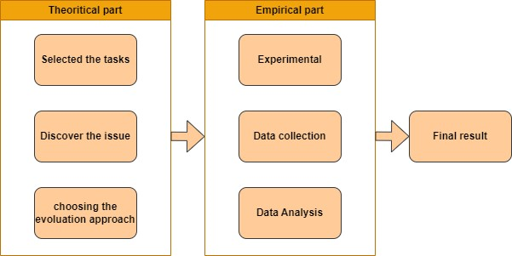
Figure 2: research process
The experiment is about six UTM students browsing websites, and engaging in various assigned tasks. Following this, students will evaluate the website's features using the components of the WAMMI questionnaire. Figure 2 provides a visual representation of the experimental procedures in this study.
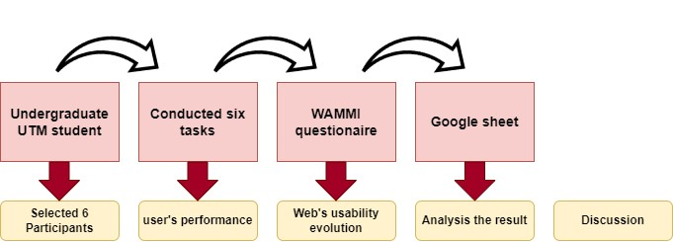
Figure 3: research process

User’s performance
In our journey to improve our website's performance and make it easier for users, we set out on an exciting adventure to uncover how people search for different types of rooms in various parts of Malaysia. We gave six individuals the task of finding six specific types of rooms, each with its unique features, making them comfortable and luxurious. These room types included:
Task 1- Family hotel room in Kuala Lumpur
Task 2- Villa with a pool in Johor Bahru
Task 3- Presidential suite in Kuala Lumpur
Task 4- Executive suite in Kuala Lumpur
Task 5 - Single hotel room in Melaka
Task 6- Connecting room in Port Dickson
Our main goal in this adventure was to figure out how easy it is for people to use our website and find these different types of rooms. We wanted to see how quickly and smoothly they could go through the steps of finding these rooms. To do this, we asked our participants to start from the Google homepage, search for Airbnb, and then enter the Airbnb website. From there, they had to look for all six room types and go through the whole process until they reached the payment page.
We carefully timed how long it took for each user to complete these tasks. This detailed approach helped us understand how they were doing and where they might be running into problems or confusion.
During the study, we paid close attention to what each user was doing. We noted the words they used in their searches, what they clicked on, and how long they spent on each step. This allowed us to not only find out how much time they spent on each room type but also to understand what they liked and didn't like about our website.
All this information is a valuable source of knowledge that helps us understand how our users experience our website. With these insights, we can work on making our website more user-friendly and efficient, so that anyone can quickly and easily find the rooms they want to book. Our mission is to use this data to make sure everyone has a smooth and enjoyable booking experience, whether they're planning a getaway in Kuala Lumpur, Johor Bahru, Melaka, or Port Dickson. We're committed to making our website as easy to use as possible, and this adventure is just one step on that journey.

Airbnb website’s evaluation
After completing the initial phase of the study, the second step involves the utilization of the WAMMI questionnaire. This questionnaire asks about the user’s satisfaction with the usability of the Airbnb website. The satisfaction rate ranges from "strongly agree=1" to "strongly disagree=5." Regarding UTM undergraduate students who participate in the testing, 50% of these students are using Airbnb as their preferred platform for hotel reservations. Approximately 16.67% of the students opt for alternative platforms such as Booking.com, Agoda, and others.
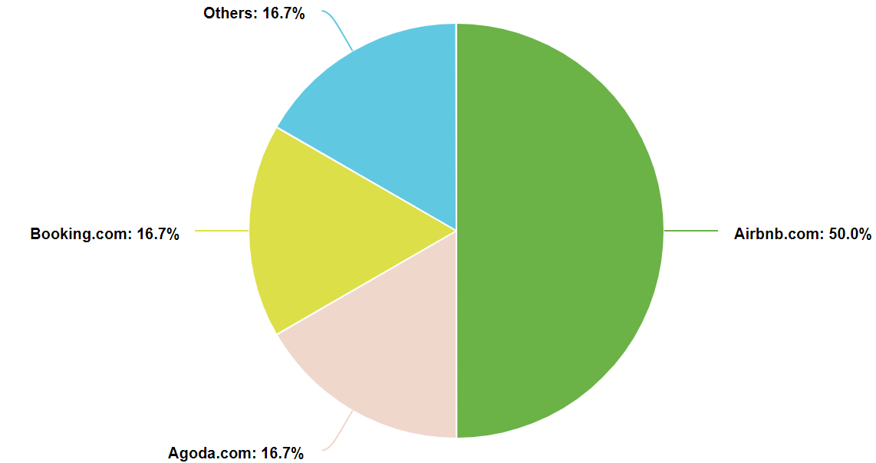
Figure 4: Platform for hotel reservation

RESULTS AND DISCUSSION
4.1 user’s performance
In our testing adventure, we explored how different users fared when looking for six types of rooms in Malaysia. Let's dive into the details a bit more:
User 1 and User 2 went for iPads, which are like big tablets, and they were connected to their special WiFi, like a private road for the internet. User 1 took about 25.5 seconds on average to find those room types using Google. User 2, while not far behind, took a little longer, around 26.17 seconds on average to do the same job.
Now, User 3 and User 4 chose laptops, which are larger and more powerful computers, and they used something called Ethernet for their internet. Surprisingly, they turned out to be the quickest of the bunch. User 3 took about 25.17 seconds, and User 4 was even quicker, managing an average of just 23.67 seconds. For User 5 and User 6, they had smartphones, which are like smaller, pocket-sized computers and their internet connections were different. User 5 used public WiFi, like what you find in places such as coffee shops, and User 6 depended on mobile data, which is like the internet you have on your phone wherever you go.
When we look at the results, User 4 was the champion in finding those room types. This is because User 4 used a laptop, which is like a supercharged computer, and they were connected to Ethernet, which is like a super-fast internet road. Laptops, especially the fancy ones, have quick brains (called CPUs), and Ethernet makes the internet super speedy.
On the flip side, User 5 took the most time to finish the task. That's because they used a smartphone. Smartphones typically have slower brains (CPUs) compared to iPads and laptops. Another reason for User 5's longer time was their internet connection. Public WiFi, like in a coffee shop, can be slow because many people use it, making it crowded and slowing everything down. So, that's why User 5 took the longest time to get the job done. In short, the choice of the device and internet connection played a big role in how quickly our users found those room types in Malaysia. Laptops with Ethernet were the fastest, while smartphones with public WiFi were the slowest.
User | Task 1 | Task 2 | Task 3 | Task 4 | Task 5 | Task 6
User1 | 28 | 26 | 25 | 27 | 23 | 24
User2 | 26 | 30 | 25 | 28 | 25 | 23
User3 | 30 | 25 | 25 | 24 | 25 | 22
User4 | 23 | 23 | 24 | 23 | 23 | 26
User5 | 35 | 29 | 33 | 29 | 27 | 28
User6 | 31 | 28 | 33 | 29 | 25 | 28
Time Taken for the 6 users to finish the specific tasks
In Task 4, all six users employed the eye-tracking tool known as GazeRecorder. This tool allowed us to track their gaze on the Airbnb website. What's particularly interesting is that all the users consistently focused on one thing: the search bar.
This makes sense as their task was to search for a specific hotel room on Airbnb. So, it's like when you open a book, your eyes go to the first page, or when you consult a map, your gaze instinctively goes to the legend. In this case, the search bar was like a guiding beacon, leading users to initiate their hotel room search. It highlights the user-friendliness of Airbnb’s website, as users naturally found their way to the important starting point for their task. The picture below shows the eye tracking heatmap of the user.
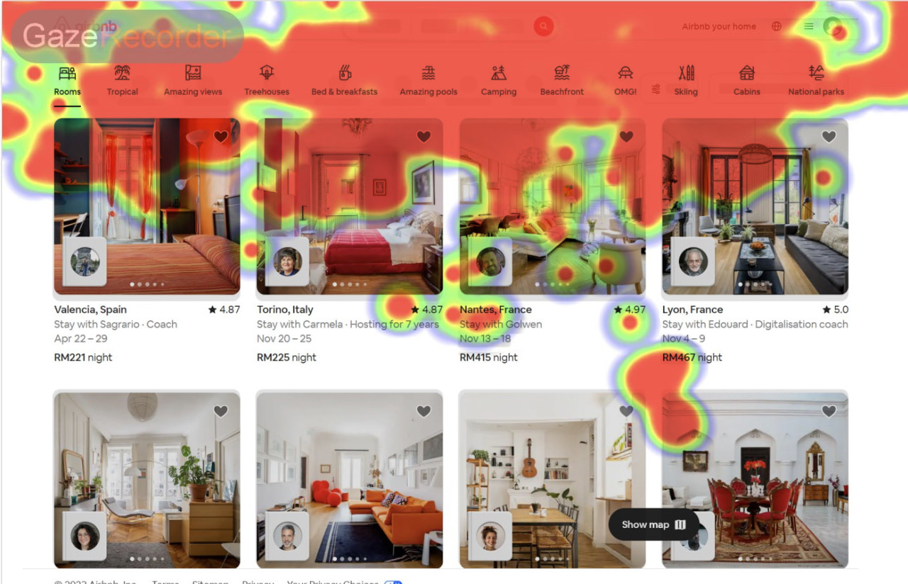
Eye Tracking Heatmap of Task 4
4.2 Website evaluation
The one-sample t-test statistic was used in the questionnaire in this study to measure the level of student satisfaction regarding the usability of the Airbnb website. The one sample t-test and five associated measures are shown in Table 2.
Besides, in one-sample t-test, the test value is defined as 3, as the current study utilized a 5-Likert point scale.
Constructs | N | Mean | Std. Deviation | Std. Error Mean
Attractiveness | 6 | 4.208 | 0.249 | 0.1015
Controllability | 6 | 4.083 | 0.289 | 0.1176
Efficiency | 6 | 4.000 | 0.360 | 0.1469
Helpfulness | 6 | 4.333 | 0.333 | 0.1361
Learnability | 6 | 3.875 | 0.369 | 0.1505
Table 3.2.1 : Result on Five Usability Factors

According to Table 3.2.1, all of the usability factors’ mean values are greater than test value (which is 3). This suggests that, on average, the usability factors in question tend to exceed the expected or reference level of 3, indicating a positive assessment of usability in the study.
Constructs | Test Value = 3
 | t | df | Critical t-Value | Mean  Difference | 95% Confidence  Interval of the  Difference
 |  |  |  |  | Lower | Upper
Attractiveness | 7.000 | 5 | 2.571 | 4.000 | 0.9477 | 1.4683
Controllability | 6.635 | 5 | 2.571 | 1.635 | 0.7806 | 1.3854
Efficiency | 5.477 | 5 | 2.571 | 1.000 | 0.6222 | 1.3778
Helpfulness | 8.000 | 5 | 2.571 | 1.333 | 0.9833 | 1.6827
Learnability | 4.213 | 5 | 2.571 | 0.875 | 0.4880 | 1.2620

Table 3.2.1: Result on Five Usability Factors (second table)

The t-value of all 5 factors are significantly greater than the critical t-value of 2.571, pointing to statistical evidence for higher satisfaction. Besides, since the t-value (8) of “helpfulness” factor is much greater than the critical t-value (2.571), it indicates that the result for "helpfulness" is statistically significant. Similar to "helpfulness," the t-value for "efficiency" is also significantly greater than the critical t-value (2.571), indicating that the result for "efficiency" is statistically significant.
The importance of conducting a usability evaluation of Airbnb's hotel reservation website is underscored by its direct impact on the user experience. The evaluation process serves as a critical mechanism to ensure that visitors to the Airbnb platform can effortlessly navigate, locate, book, and manage accommodations, ultimately resulting in heightened levels of user satisfaction. This user-centric approach is pivotal in enhancing Airbnb's competitiveness and solidifying its position as a preferred choice among travelers. At the core of this endeavor, the central aim of the present study is to comprehensively assess the usability of Airbnb's website. In this digital age where online booking platforms play a pivotal role in travel arrangements, such assessments become instrumental in shaping the quality of user interactions and driving business success. By addressing usability concerns, Airbnb can better serve the diverse needs and preferences of its vast and ever-expanding user base. In essence, this study aspires to serve as a catalyst for enhancing the user experience on Airbnb's hotel reservation website. Beyond Airbnb, the
results and insights garnered from this evaluation are expected to extend their influence to the broader online travel and e-commerce industry. By shining a spotlight on usability and user-centric design, we can collectively work towards crafting digital interfaces that not only meet user expectations but also anticipate and exceed them. In an ever-evolving digital landscape, the significance of such efforts cannot be overstated.
This research was separated into two parts: The chosen students first completed a variety of tasks to learn how the Airbnb website works. The students are then asked to complete a survey about how well the Airbnb website works. The usability elements used to evaluate the usability of the Airbnb website included attractiveness, controllability, efficiency, helpfulness, and learnability. The results indicate that five factors are satisfactory for the visitors to the Airbnb website. The "Helpfulness" factor is most satisfied by customers while the "Learnability" factor is less satisfied by the customers compared to the other four factors.
Therefore, user-centric content must be enabled on hotel booking services like Airbnb. Airbnb may choose to curate user-centric content to improve learnability. This entails offering educational manuals, frequently asked questions and instructional videos. These resources can help users traverse the platform's numerous functions, from looking for a particular kind of lodging to managing their reservations. By making these resources easily accessible, users can educate themselves on how to make the most of Airbnb's features.
Moreover, the significance of this study extends well beyond the boundaries of any single website. Its anticipated results are poised to serve as a guiding light for the development of enhanced and more user-friendly websites. The focus is not solely on Airbnb, but rather on contributing to the broader landscape of hotel reservation websites. By scrutinizing the strengths and weaknesses of the Airbnb website, this study seeks to offer insights that have the potential to elevate user experiences on various platforms. The goal is to create a roadmap, one that other online hotel reservation websites can follow, forging a path toward user-centric design and enhanced satisfaction for their visitors. In addition to the obvious benefits for Airbnb, the implications are broader and include additional important market competitors, such as Booking.com and Agoda. These platforms can benefit from the findings of this study because they are important players in the world of digital booking platforms. The importance of interface design and usability in determining user preferences is highlighted. Because the user interface of a website or application will have a significant impact on potential customers, the researchers advise performing additional empirical studies to assess the usability of hotel reservation websites like Booking.com and Agoda.

5. CONCLUSION
In the course of our usability evaluation of the Airbnb website, we have uncovered key findings that illuminate critical aspects of user experience and satisfaction. Notably, the "Helpfulness" factor emerges as the most satisfying aspect for users, underscoring the platform's success in empowering users to efficiently navigate, search, and engage with accommodation listings. This high level of satisfaction with "Helpfulness" is a testament to Airbnb's commitment to user-centered design and ongoing improvements.
Conversely, our evaluation reveals that the "Learnability" factor represents a notable area for improvement. Users expressed less satisfaction with the ease of learning to use the platform, particularly for new users. While Airbnb excels in facilitating interactions for returning users, there is an opportunity to enhance onboarding and educational resources for individuals new to the platform.

These key aspects are instrumental in shaping the overall user experience on Airbnb and are pivotal for the platform's continued success. Our findings underscore the paramount importance of user-centered design in online platforms, particularly those in the sharing economy. By addressing learnability challenges, Airbnb can further elevate the user experience, ensuring that users of all levels of familiarity can efficiently and satisfactorily interact with the platform.
In conclusion, this usability evaluation is not merely an analytical exercise; it serves as a guide for ongoing improvements and innovation. As technology continues to evolve, and user expectations grow, the usability and user experience of platforms like Airbnb will remain central to their competitiveness and long-term success. The lessons learned from this evaluation extend beyond Airbnb to other online platforms, fostering a culture of user-centric design and a commitment to continually enhance user interactions in the digital age. Ultimately, this research underscores the pivotal role of user experience in shaping the future of the sharing economy and digital platforms, enriching user satisfaction and efficiency in interactions.

6. ACKNOWLEDGEMENT
We extend our heartfelt gratitude to the UTM undergraduate students who wholeheartedly participated in this study. Their invaluable contributions, dedication, and cooperation have been instrumental in making this research endeavor a success.

7. REFERENCE
- “Usability 101: Introduction to Usability,” Nielsen Norman Group. http://www.nngroup.com/articles/usability-101-introduction-to-usability/. [Accessed Oct. 24, 2023]
- J. R. Lewis and J. Sauro, “USABILITY AND USER EXPERIENCE: DESIGN AND EVALUATION,” HANDBOOK of HUMAN FACTORS and ERGONOMICS, pp. 972–1015, Aug. 2021, doi: 10.1002/9781119636113.ch38. [Accessed Oct 24, 2023]
- L. Marques et al., “Understanding UX Better: A New Technique to Go beyond Emotion Assessment,” Sensors, vol. 21, no. 21, p. 7183, Oct. 2021, doi: 10.3390/s21217183. [Accessed Oct 24, 2023].
- “What is Usability - The Ultimate Guide,” The Interaction Design Foundation, Oct. 13, 2023. http://www.interaction-design.org/literature/topics/usability. [Accessed Oct. 25, 2023].
- Wikipedia contributors, “Web usability,” Wikipedia, Aug. 29, 2023. https://en.wikipedia.org/wiki/Web_usability. [Accessed Oct 24, 2023]
- Airbnb. “Vacation Rentals, Homes, Experiences & Places - Airbnb.” Airbnb, Airbnb, 2023, www.airbnb.com/. [Accessed Oct 24, 2023]
- A. B. Naeini, A. G. Mahdipour, and R. Dorri, “Using eye tracking to measure overall usability of online grocery shopping websites,” International Journal of Mobile Computing and Multimedia Communications, vol. 14, no. 1, pp. 1–24, Jul. 2023, doi: 10.4018/ijmcmc.326129.
- J. K. and N. Claridge, “WAMMI - home.” http://www.wammi.com/index.html [Accessed Oct 24, 2023]
- S. A. Mentes and A. H. Turan, “Assessing the usability of university websites: An empirical study on Namik Kemal University,” ResearchGate, Jul. 2012, [Online]. Available: https://www.researchgate.net/publication/286895357_Assessing_the_usability_of_university_websites_An_empirical_study_on_Namik_Kemal_University. [Accessed Oct 24, 2023]
- A. Ahmad, A. Hussain, O. Hamid, and M. I. Sabri, “Utilizing WAMMI components to evaluate the usability of e-commerce website,” ResearchGate, Nov. 2020, [Online]. Available: https://www.researchgate.net/publication/346470810_Utilizing_WAMMI_Components_to_Evaluate_the_Usability_of_E-commerce_Website. [Accessed Oct 20, 2023]

8. AUTHOR’S PROFILE


Chan Qing Yee
A22EC0040
Computer Network and Security Faculty of Computing, UTM
chan.yee@graduate.utm.my


Ong Kai Xuen
A22EC0100
Computer Network and Security Faculty of Computing, UTM
ongxuen@graduate.utm.my



Lim Si Ni
A22EC0070
Computer Network and Security Faculty of Computing, UTM
ni-02@graduate.utm.my


Soh Fei Zhen
A22EC0272
Computer Network and Security Faculty of Computing, UTM
soh.zhen@graduate.utm.my



Ooi Wei Sian
A22EC0102
Computer Network and Security Faculty of Computing, UTM
ooisian@graduate.utm.my

